Ascender Bank Reconciliation Tips and Tools

Items to check if you have an Unreconciled Difference:

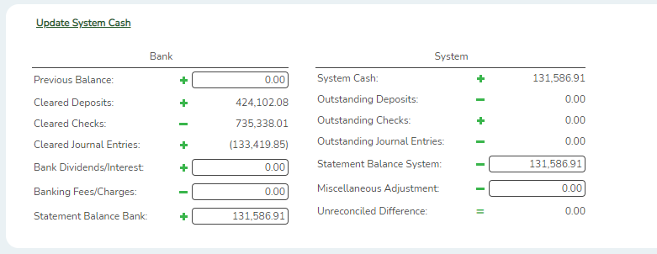
- Reconcile Cleared Deposits and Cleared Checks on bank statement with cleared deposits/checks on bank reconciliation screen.

- Verify actual cash transferred to payroll bank account equals system entry. Make sure to look at all payrolls for the month. Include Stat. Min., Non-OASDI and the Child Nutrition portion, which has its own separate interface. Also, be
aware of Special Adjustments which may require transfers.
(Recommended report to assist in verifying this is the General Journal FIN1150).

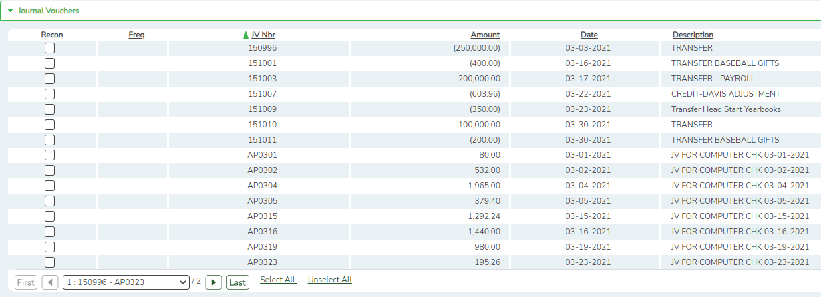
- Confirm an entry was made for bank charges.

- Confirm an entry was made for NSF charges.

- Confirm an entry was made for Interest Credit.

- Verify if any prior months’ miscellaneous adjustments or transfers are still outstanding.

- Verify outstanding checks from prior month are still listed as outstanding in the current month.
- Verify all funds/cash objects are accounted for on the Bank Account Group Funds Table. Compare with General Ledger Account Summary screen for the cash object codes to determine if any cash objects are missing from the tables.

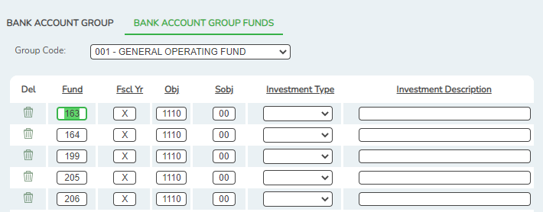

- Look for Journal Vouchers entered which affect the cash accounts.

- Verify that no transactions were posted after previous month’s reconciliation was completed.

- Keep in mind that some of the journal entries are not being created during the Create Transactions process. This is because the system is recognizing the journal entry as a duplicate. The journal entry information will not populate on the bank rec screen, unless you manually add the information on the Transaction Maintenance screen.
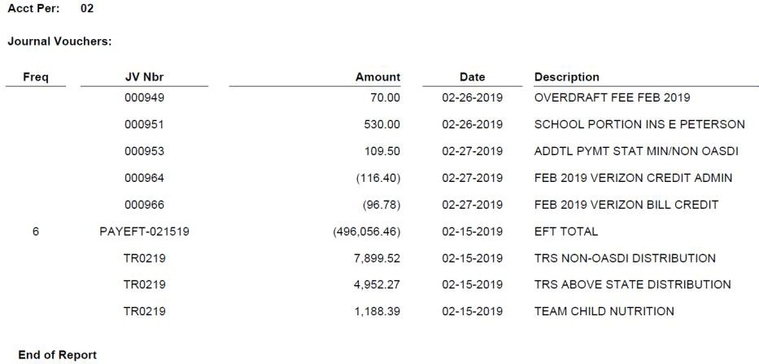
The P60215 entry, which was interfaced on 02-13-2019, was not created in the Create Transactions process because it is a duplicate entry number from the previous year.

